M&C IT Weekly Status Reporting submission Guidance – 2012

Contents
M&C IT PM Tool Report Submission Process 3
1. Knowing your reports. 3
2. Reports on SharePoint. 3
3. Collating the current week’s status report. 5
4. Completed and Submitting Reports 6
5. Program Manager 2 page report...............................................................................................7

M&C IT PM Tool Report Submission Process

Knowing your reports.
There are 2 types of report compiled to complete the M&C Weekly status reports.
- Program Managers Reports – These are program status workstream reports submitted weekly by Program Managers.
- Messaging comprising of Lync & Outlook/Exchange
- Collaboration
- D&ME
- Change Management
- Transition Management
- Business Deployment
- Microsoft
- IAM
(2) PMO reports –These are reports submitted by PMO covering the M&C Program in areas listed below.
- Planning
- Finance
- Resourcing
- Change Control
- RAIDs
- Quality
- Vendor Management

Reports on SharePoint.

These reports are submitted uploaded here weekly on Thursday’s by 3pm UK time.
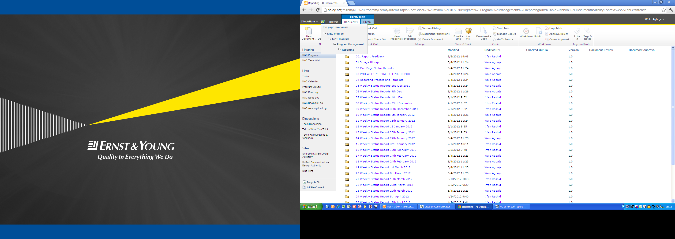
Steps to getting to the reports –
- Link the SharePoint site here
- Click M&C Program on the left column.

- Click Program management in the list of folders
- Click reporting folder in the list of folders
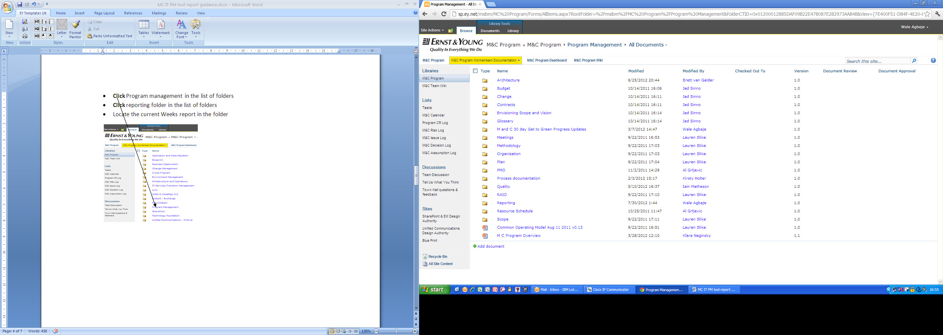
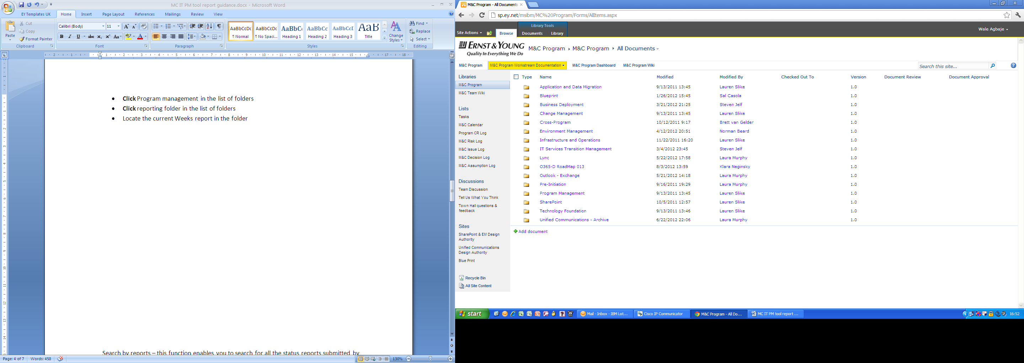
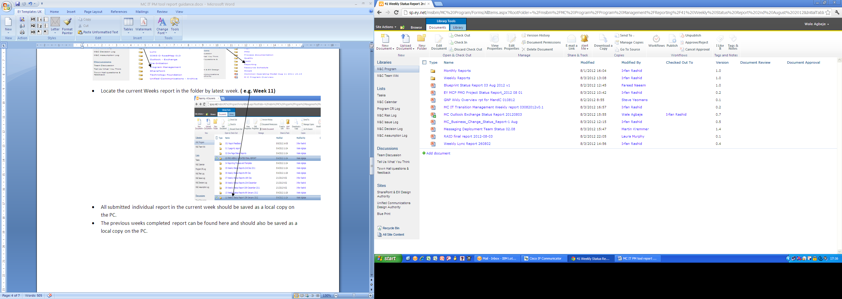
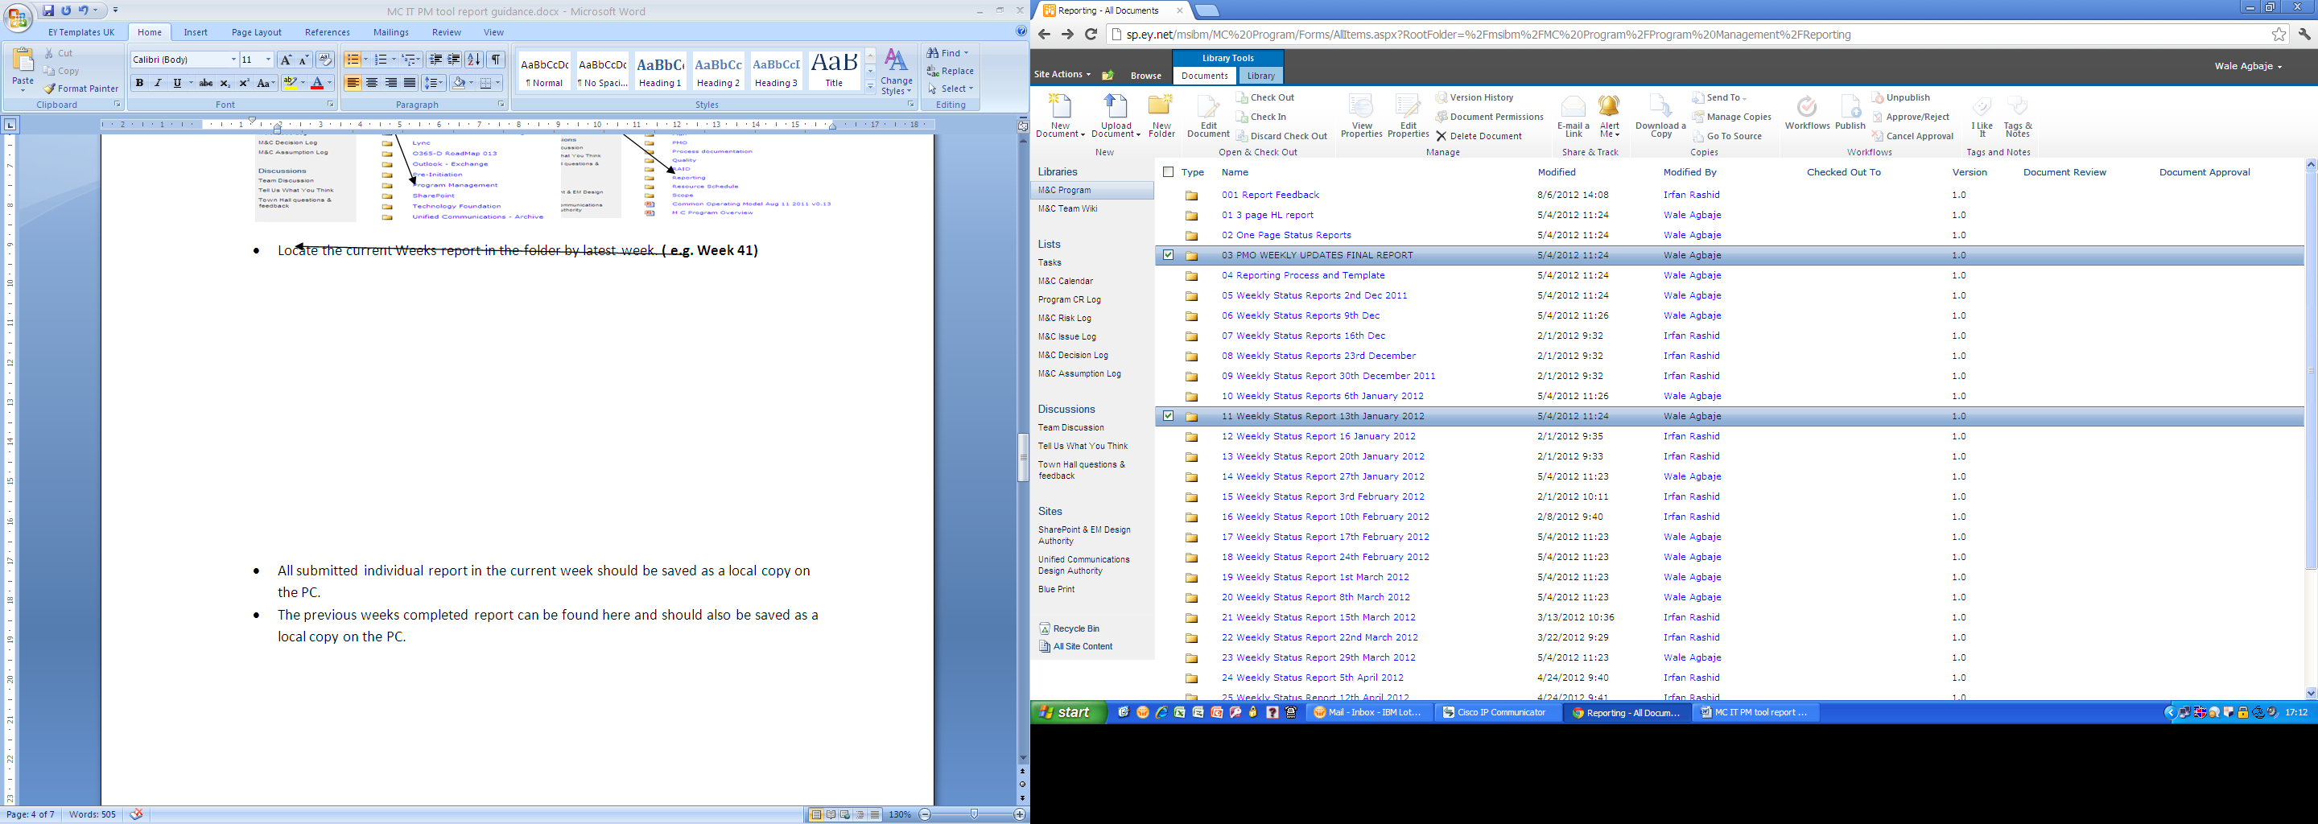
- Locate the current Weeks report in the folder by latest week. ( e.g. Week 11)

- All current submitted individual reports in the current week should be saved as a local copy on the PC.
- The previous week completed report can be found here and should also be saved as a local copy on the PC.

Collating the current week’s status report.

- The already saved report should be dated the next/following Tuesday that the M&C status meeting will be taking place.
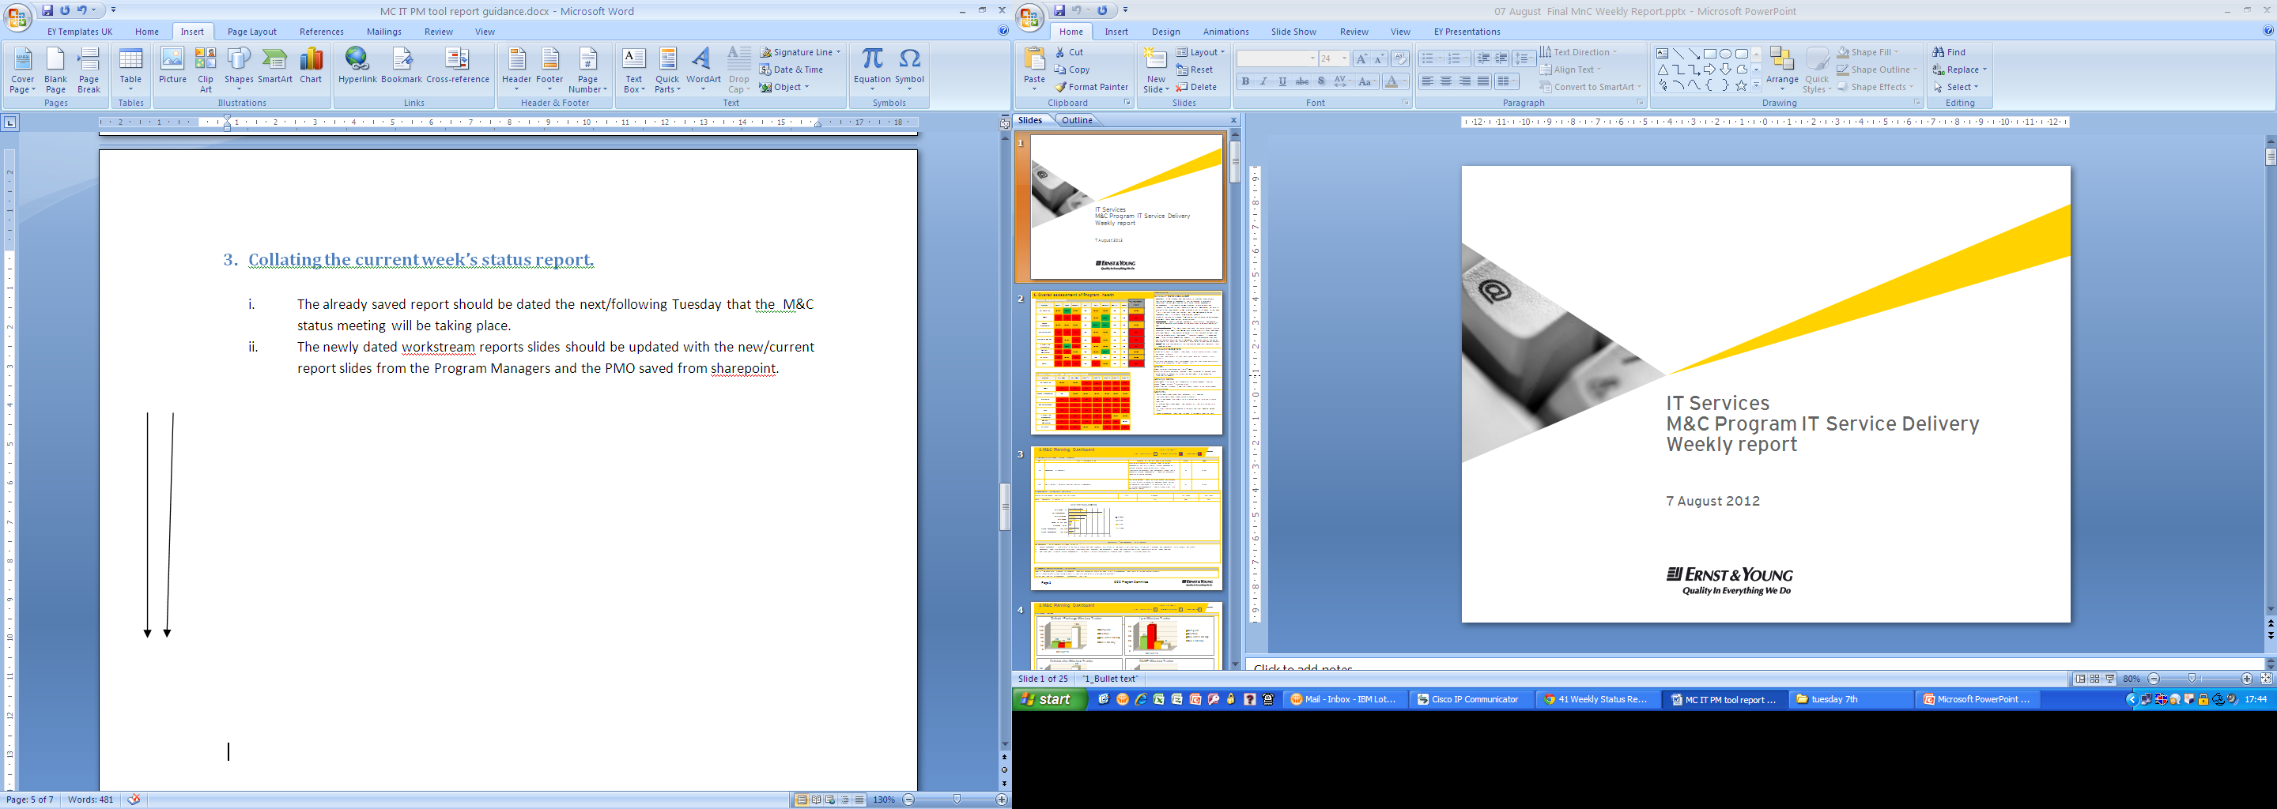
- The newly dated workstream reports slides should be updated and replaced with the new/current report slides from the Program Managers and the PMO saved on local PC copy from SharePoint.

- After all the old slides on the previous week’s report have been updated/replaced on the new status report, PMO narrative should be extracted from the PMO reports and included on slide 2 PMO narrative section.
- The Program health section has 3 RAG assessment sections.
- PM Report View – This column on slide of titled Overall assessment of program health is populated with the RAG statuses from the Program Managers workstream reports.
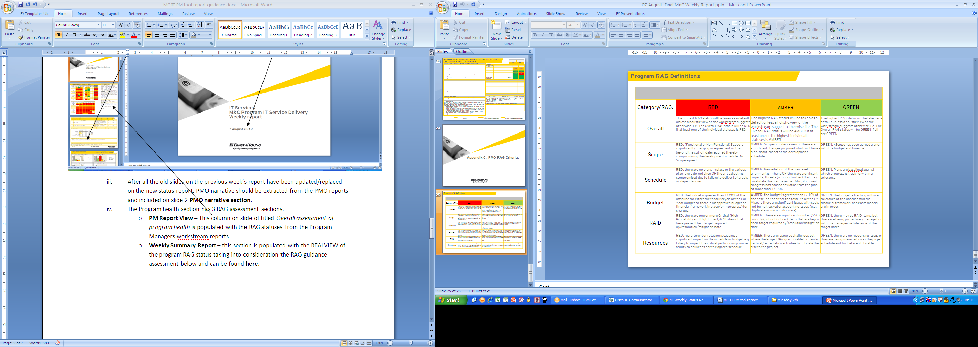
- Weekly Summary Report – this section is populated with the REALVIEW of the program RAG status taking into consideration the RAG guidance assessment below. Original doc and can be found here.

- Weekly Program RAG Assessment Trend - This is the weekly cumulative RAG assessment of the REALVIEW of the program reporting detailed over 6 weeks.

Completed and Submitting Reports
- The completed report should be sent to the PMO Manager for review on Monday no later than 10am.
- After review the completed report should be sent to the M&C program manager for approval before distribution to the wider M&C audience.
- After approval by the program manager the doc should be uploaded back to SharePoint in folder PMO WEEKLY UPDATES FINAL REPORT folder and dated the same date Tuesday on the completed report.
- A smart link of the uploaded report should now be sent out to all those that attend the weekly M&C status update meeting, list can be found in the minutes here.

Program Manager 2 page report.

- This report consists of a 2 page report sent to the program manager with the Program weekly report for review, both reports are sent in the same email,
- The 2 page report is compiled using the overall assessment program health slide in the weekly report, below is a sample of a completed report.
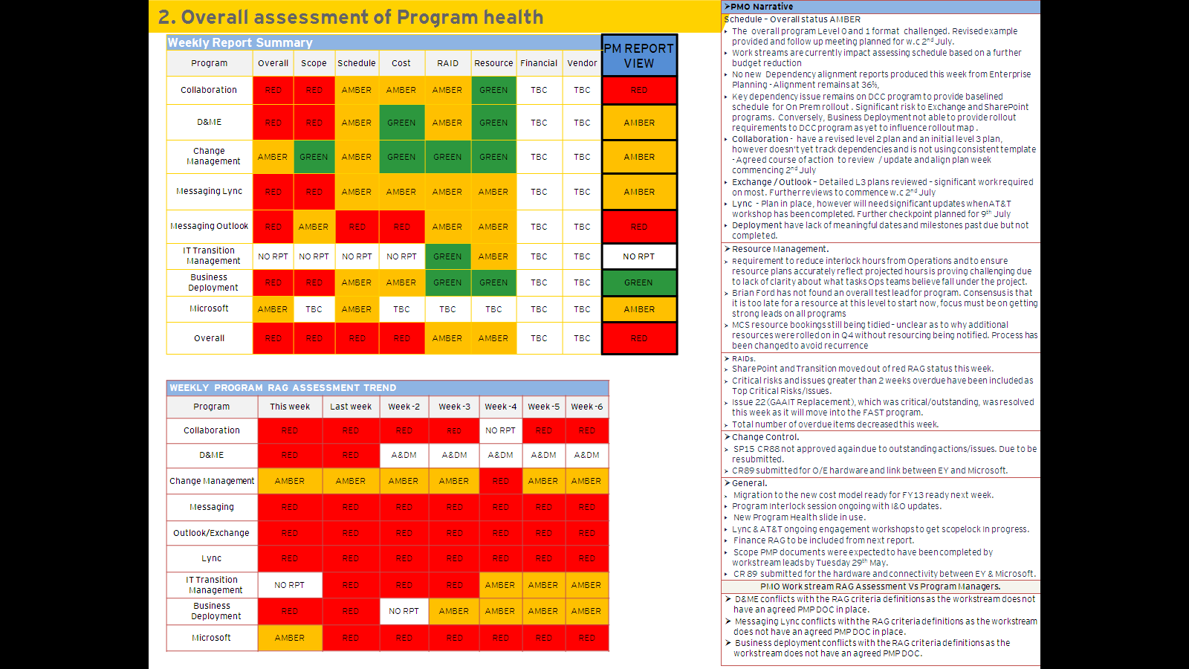

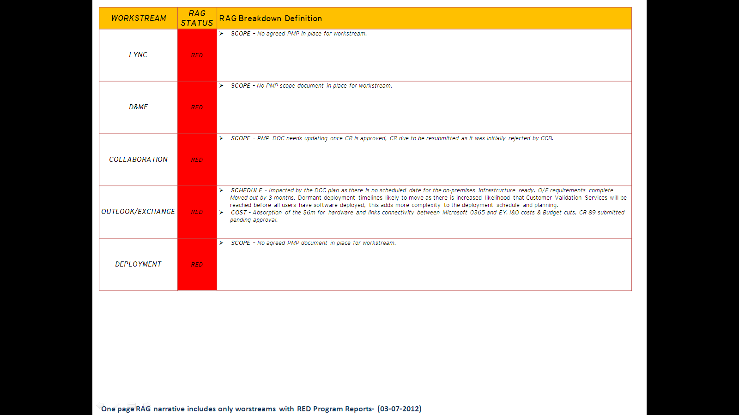
- Each workstream with a Red RAG status is extracted and put in the template below, Template can be found here.

- Red Item’s only in the program health assessment are highlighted in the template.
- All RED items are investigated and defined as done in the completed picture above.

